DOWNING DRIVE SURGERY
155 DOWNING DRIVE, EVINGTON, LEICESTER, LE5 6LP
Tel 0116 2413801

The Complaint Process

At Downing Drive Surgery, we are committed to providing high-quality care and services. However, we understand that there may be times when you feel dissatisfied with the treatment or care you have received. We value your feedback and use it to improve our services and patient experience.

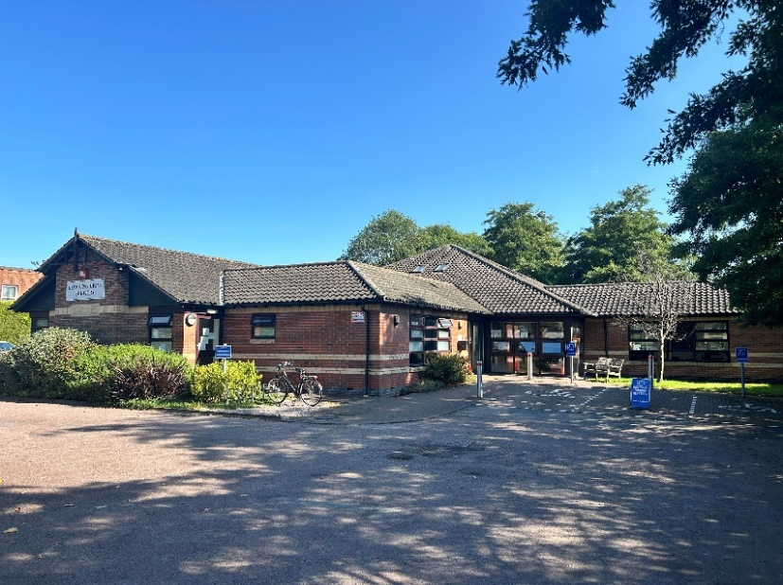

- HOW TO COMPLAIN
We aim to resolve most problems easily and quickly, often at the time they arise and with the person involved. For simple issues, you can speak with our Office Supervisor or Operations Manager, Salma Patel. If your concern cannot be resolved informally and you wish to make a formal complaint, we encourage you to let us know as soon as possible. Prompt reporting allows us to investigate the matter thoroughly and efficiently. If immediate reporting is not possible, formal complaints should be submitted within 12 months of the incident in question.

How to submit a formal complaint?
- By Phone: Contact the Practice on 0116 241 3801 and ask to speak with the Practice Manager, Katie Billson. If Katie is unavailable, you can leave a message requesting a call back or contact the practice again at a more convenient time.
- In writing: Address your letter to the Practice Manager and send it to the Surgery’s address above.
- By Email: Send your formal complaint to: Downingdrivesurgery.noreply@nhs.net

Complaining on behalf of someone else?
We adhere strictly to the rules of medical confidentiality. If you are making a complaint on behalf of a patient, we will require their permission to proceed. This includes providing a signed authority from the patient unless they are unable to do so due to illness or incapacity. A Third-Party Consent Form is available below for this purpose.

- HOW WE WILL HANDLE YOUR COMPLAINT
If we are unable to resolve your complaint immediately, we will acknowledge your written complaint within three working days and outline the next steps for investigating your concern. We will, where possible, provide an estimated timescale for resolution. If we are unable to give a precise timeframe, we will keep you informed of progress, ensuring you are regularly updated.

During our investigation, we aim to:
- Conduct a thorough investigation: We will speak with all parties involved to fully understand what happened and identify any issues.
- Provide regular updates: We will keep you informed of our progress throughout the investigation.
- Offer a timely response: While we strive to respond as quickly as possible, some complaints may take longer to resolve. We will inform you of any delays and provide updates via your preferred method—phone, email, or letter.
- Provide a thoughtful resolution: You can expect a detailed and thoughtful response to your complaint.
- Take action to improve: If we identify areas for improvement, we will share the steps we are taking to prevent similar issues in the future.

Once the investigation is complete, we will either provide a written response with an explanation or arrange a meeting with the relevant parties involved to discuss the outcome.

- IF YOU REMAIN DISSATISFIED
If you are not satisfied with the outcome of our investigation of your complaint, you can ask for an
independent review of your case by writing to:

The Parliamentary and Health Service Ombudsman
Millbank Tower
30 Millbank
London
SW1p 4QP
Telephone: 0345 0154033
Website: www.ombudsman.org.uk

- COMPLAINING TO NHS LLR ICB
We hope that, if you have a problem, you will use our practice complaints procedure. We believe this will give us the best chance of putting right whatever has gone wrong and will be an opportunity to improve our practice. This does not affect your right to approach the Leicester, Leicestershire and Rutland (LLR) Integrated Care Board (ICB) if you feel that you cannot raise your complaint with us.

Their contact details are:
- Telephone: 0116 295 7572
- Email: llricb-llr.enquiries@nhs.net
- Post: NHS LLR ICB, Room G30, Pen Lloyd Building, County Hall, Glenfield, Leicester, LE3 8TB

- OTHER SERVICE PROVIDERS
If your complaint is about other service providers (hospital, or the District Nurses) please contact:
- UHL – PILS Team. Telephone: 0808 1788 337 or Email: pils@uhl-tr.nhs.uk
- LPT – PALS Team. Telephone: 0116 295 0830 or Email: PALS@leicspart.nhs.uk

Downing Drive Surgery
155 Downing Drive, Evington, Leicester, LE5 6LP

Complaints form

We are committed to providing the best possible care and service to our patients. If you feel we have fallen short, we would like to hear from you to help us improve. Please complete this form and return it to the reception, or send it to Downingdrivesurgery.noreply@nhs.net

- PATIENT DETAILS
Full name:
Date of Birth (DOB):
NHS no. if known:
Preferred Contact no.:
Address:
Email:

- ARE YOU THE PATIENT?
If you are making this complaint on behalf of the patient, please provide your details below and explain your relationship to the patient. If you do not have consent, we will ask you to return a consent form signed by the patient.

Your full name:
Relationship to patient:
Do you have the patient’s consent to make this complaint: | YES / NO
Preferred Contact no.:

- DETAILS OF THE COMPLAINT
Date of Incident:
Time of incident (if known):
Location (e.g., Surgery, phone consultation etc.):
Details of the incident or issue you are complaining about:

Continued…

If you require more space, please attach more pages.
People/staff involved:

- DESIRED OUTCOME
What would you like to happen as a result of this complaint?

- SIGNATURE
Patient Signature:
Date:
If signed on behalf of the patient: | Your signature:  Date:
Preferred Contact no.:

- OFFICE USE ONLY
Date complaint received:
Received by:
Action taken:

Downing Drive Surgery

PATIENT THIRD-PARTY CONSENT

Patient’s name:
Telephone number:
Address:
Complainant name:
Telephone number:
Address:

IF YOU ARE COMPLAINING ON BEHALF OF A PATIENT OR YOUR COMPLAINT OR ENQUIRY INVOLVES THE MEDICAL CARE OF A PATIENT THEN THE CONSENT OF THE PATIENT WILL BE REQUIRED. PLEASE OBTAIN THE PATIENT’S SIGNED CONSENT BELOW.

DECLARATION:
I fully consent to my Doctor releasing information to, and discussing my care and medical records with the person named above in relation to this complaint only, and I wish this person to complain on my behalf.

This authority is for an indefinite period / for a limited period only (delete as appropriate)

Where a limited period applies, this authority is valid until…………………….. (insert date)

Signed by the patient:
Date:

